Task 7: Interactive Web Form with Events & Functions
Aim: To implement an Automated Logging System using MySQL Triggers and Views, where every INSERT and UPDATE operation is automatically recorded, and daily activity reports are generated.
Algorithm (Step-by-Step)
Step 1: Create Database
- Create a database to store transaction and audit data.
Step 2: Create Tables
- Create transactions table to store user data.
- Create audit_log table to store logs.
Step 3: Create Triggers
- Create an INSERT trigger
  - When a new record is added → log the action.
- Create an UPDATE trigger
  - When a record is updated → store old and new values.
Step 4: Create View
- Create a daily_activity view
- It groups logs based on date and shows total actions.
Step 5: Setup Backend (Node.js)
- Connect Node.js with MySQL.
- Create APIs:
  - Insert transaction
  - Update transaction
  - Fetch logs
  - Fetch daily report
Step 6: Create Frontend
- Create HTML form to input data.
- Use JavaScript to send data to backend.
- Display logs in table format.
Step 7: Execute Project
- Run server.
- Perform insert/update operations.
Program:
Index.html
<!DOCTYPE html>
<html>
<head>
<title>Audit Logging System</title>
</head>
<body>
<h2>Transaction System</h2>
<input id="name" placeholder="User Name">
<input id="amount" placeholder="Amount">
<button onclick="add()">Add</button>
<button onclick="update()">Update ID 1</button>
<h2>Logs</h2>
<button onclick="loadLogs()">Load Logs</button>
<table border="1">
<thead>
<tr>
<th>ID</th>
<th>Txn ID</th>
<th>Action</th>
<th>Old</th>
<th>New</th>
<th>Time</th>
</tr>
</thead>
<tbody id="logs"></tbody>
</table>
<script>
const API = "http://localhost:3000";
function add() {
fetch(`${API}/transaction`, {
method: "POST",
headers: {"Content-Type": "application/json"},
body: JSON.stringify({
user_name: document.getElementById("name").value,
amount: document.getElementById("amount").value,
action_type: "PAYMENT"
})
}).then(r => r.json()).then(alert);
}
function update() {
fetch(`${API}/transaction/1`, {
method: "PUT",
headers: {"Content-Type": "application/json"},
body: JSON.stringify({
amount: document.getElementById("amount").value
})
}).then(r => r.json()).then(alert);
}
function loadLogs() {
fetch(`${API}/logs`)
.then(r => r.json())
.then(data => {
let rows = "";
data.forEach(l => {
rows += `
<tr>
<td>${l.log_id}</td>
<td>${l.transaction_id}</td>
<td>${l.action}</td>
<td>${l.old_amount || "-"}</td>
<td>${l.new_amount || "-"}</td>
<td>${l.log_time}</td>
</tr>
`;
});
document.getElementById("logs").innerHTML = rows;
});
}
</script>
</body>
</html>
Service.js
const mysql = require("mysql2");
const cors = require("cors");
const app = express();
app.use(cors());
app.use(express.json());
app.use(express.urlencoded({ extended: true }));

// DB CONNECTION
const db = mysql.createConnection({
host: "localhost",
user: "root",
password: "MySQL@1234",
database: "audit_demo1"
});
db.connect(err => {
if (err) {
console.log("DB Connection Error:", err);
} else {
console.log("MySQL Connected");
}
});
app.post("/transaction", (req, res) => {
const { user_name, amount, action_type } = req.body;
console.log("INSERT BODY:", req.body);
if (!user_name || !amount) {
return res.status(400).send("Missing required fields");
}
const sql = "INSERT INTO transactions (user_name, amount, action_type) VALUES (?, ?, ?)";
db.query(sql, [user_name, amount, action_type], (err, result) => {
if (err) {
console.log(err);
return res.send(err);
}
res.send({
message: "Inserted successfully",
id: result.insertId
});
});
});
app.put("/transaction/:id", (req, res) => {
const { amount } = req.body;
console.log("UPDATE ID:", req.params.id, "BODY:", req.body);
if (!amount) {
return res.status(400).send("Amount is required");
}
const sql = "UPDATE transactions SET amount=? WHERE id=?";
db.query(sql, [amount, req.params.id], (err, result) => {
if (err) {
console.log(err);
return res.send(err);
}
res.send({
message: "Updated successfully",
id: req.params.id
});
});
});
app.get("/logs", (req, res) => {
db.query("SELECT * FROM audit_log ORDER BY log_time DESC", (err, result) => {
if (err) return res.send(err);
res.json(result);
});
});
app.get("/report", (req, res) => {
db.query("SELECT * FROM daily_activity", (err, result) => {
if (err) return res.send(err);
res.json(result);
});
});
app.listen(3000, () => {
console.log("Server running on http://localhost:3000");
});
Package.json
{
"name": "audit-logging-project",
"version": "1.0.0",
"description": "",
"main": "server.js",
"scripts": {
"test": "echo \"Error: no test specified\" && exit 1",
"start": "node server.js"
},
"keywords": [],
"author": "",
"license": "ISC",
"type": "commonjs",
"dependencies": {
"cors": "^2.8.6",
"express": "^5.2.1",
"mysql2": "^3.22.0"
}
}

Output: 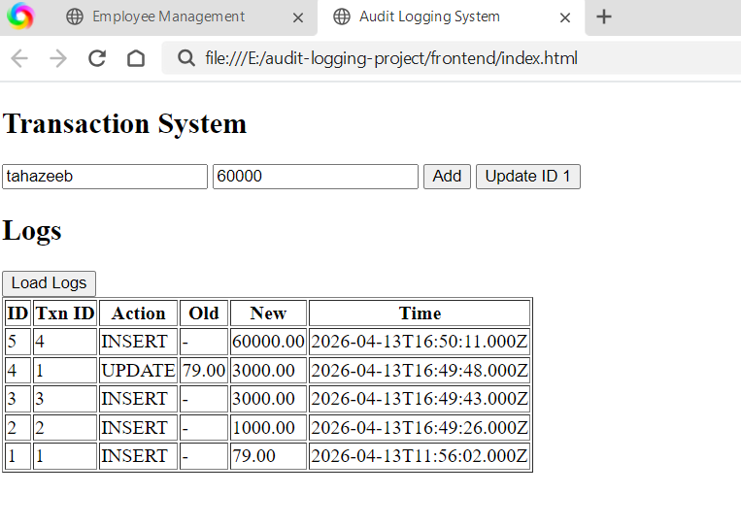

Result:
All INSERT and UPDATE operations are automatically recorded in the audit log table using triggers. Old and new values of updated records are successfully tracked for auditing. The daily activity view provides a summary of total actions performed each day.

